Create a nojs and jquery WebPart

1. Create a Spfx webpart jqueryexample

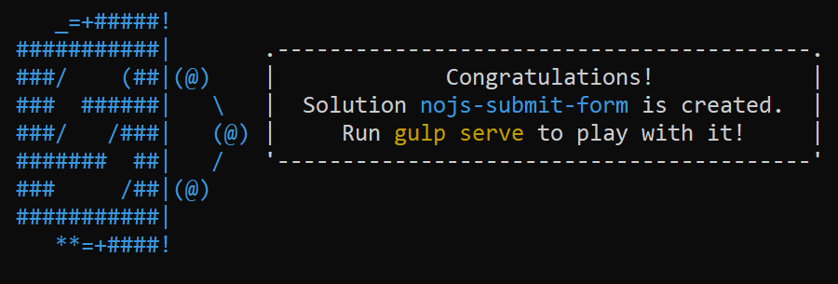

Open the project in visual studio code using > code .

We need to include Text box, People picker, Date control, drop down

After finished creating the WebPart solution using Yo generator install the jquery and jqueryui using the below commands

npm install jquery@2

npm install jqueryui

npm install @types/jquery@2 --save-dev

npm install @types/jqueryui --save-dev

Add external references to the config.json file  
Locate the config.json file under the config folder and add the below entry to the file

**"externals": {**

"jquery": "node_modules/jquery/dist/jquery.min.js",

"jqueryui": "node_modules/jqueryui/jquery-ui.min.js"

**}**

Add a new file **MyAccordionTemplate.ts** in the **./src/webparts/** jqueryexample folder.

export default class MyAccordionTemplate {

public static templateHtml: string = `

<div class="accordion">

<h3>Section 1</h3>

<div>

<p>

Mauris mauris ante, blandit et, ultrices a, suscipit eget, quam. Integer

ut neque. Vivamus nisi metus, molestie vel, gravida in, condimentum sit

amet, nunc. Nam a nibh. Donec suscipit eros. Nam mi. Proin viverra leo ut

odio. Curabitur malesuada. Vestibulum a velit eu ante scelerisque vulputate.

</p>

<i style="color:blue">Click here</i>

</div>

<h3>Section 2</h3>

<div>

<p>

Sed non urna. Donec et ante. Phasellus eu ligula. Vestibulum sit amet

purus. Vivamus hendrerit, dolor at aliquet laoreet, mauris turpis porttitor

velit, faucibus interdum tellus libero ac justo. Vivamus non quam. In

suscipit faucibus urna.

</p>

</div>

<h3>Section 3</h3>

<div>

<p>

Nam enim risus, molestie et, porta ac, aliquam ac, risus. Quisque lobortis.

Phasellus pellentesque purus in massa. Aenean in pede. Phasellus ac libero

ac tellus pellentesque semper. Sed ac felis. Sed commodo, magna quis

lacinia ornare, quam ante aliquam nisi, eu iaculis leo purus venenatis dui.

</p>

<ul>

<li>List item one</li>

<li>List item two</li>

<li>List item three</li>

</ul>

</div>

<h3>Section 4</h3>

<div>

<p>

Cras dictum. Pellentesque habitant morbi tristique senectus et netus

et malesuada fames ac turpis egestas. Vestibulum ante ipsum primis in

faucibus orci luctus et ultrices posuere cubilia Curae; Aenean lacinia

mauris vel est.

</p>

<p>

Suspendisse eu nisl. Nullam ut libero. Integer dignissim consequat lectus.

Class aptent taciti sociosqu ad litora torquent per conubia nostra, per

inceptos himenaeos.

</p>

</div>

</div>`;

}

Go to webpart class file ExamplejqueryWebPart.ts

Import below packages

|  |
| --- |
|  |

import MyAccordionTemplate from './MyAccordionTemplate';

import * as jQuery from 'jquery';

import 'jqueryui';

import { SPComponentLoader } from '@microsoft/sp-loader';

add constructor

public constructor() {

super();

SPComponentLoader.loadCss('//code.jquery.com/ui/1.11.4/themes/smoothness/jquery-ui.css');

}

Replace render method

public render(): void {

this.domElement.innerHTML = MyAccordionTemplate.templateHtml;

const accordionOptions: JQueryUI.AccordionOptions = {

animate: true,

collapsible: false,

icons: {

header: 'ui-icon-circle-arrow-e',

activeHeader: 'ui-icon-circle-arrow-s'

}

};

jQuery('.accordion', this.domElement).accordion(accordionOptions);

jQuery("i").click(()=>{

      alert("clicked click here");

    });

}